**Problem/Opportunity:**

A quarter of Home Town residents face food insecurity. We have a dollar store with limited fresh produce. The nearest grocery story is 20 miles away. Many low-income residents do not travel to the grocery store and instead shop at the local dollar store. There access to fresh fruits and vegetables is limited.

**Our Solution:**

Our weekly market will be held Saturday morning at Home Town Park. Saturday mornings are busy times at the park with organized youth sports and other recreation attracting residents, especially families, year-round. The market will be highly visible and will accept food stamps. The hospital will provide vouchers to patients with children under five and others with certain chronic conditions to further incentivize market participation.

**Target Market:**

All residents of Home Town, but especially low-income residents who travel to purchase groceries less frequently.

**Our Competition:**

Neighboring Town about 20 miles away has a farmers market. Theirs is held on Friday nights whereas ours will be Saturday morning. Many of our target customers are low income and do not drive to Neighboring Town regularly.

We will also be competing with canned foods and other foods at the dollar store and convenience stores.



**Business Goals:**

1. 10 vendors at 6 mos, 20 of whom are weekly.
2. 200 customers weekly
3. Consumers consume

**Strategies to Achieve Goals:**

* 1. Advertise to all farmers in surrounding counties
  2. Have 10 vendor applications 2 mos before market opens

1-3 The market will open with 5 vendors

2-1 Advertise in newspaper, social media, radio and school flier

2-2 Sandwich boards up Fridays and Saturdays

2-3 Hospital vouchers

2-4 SNAP accepted

**Benchmarks:**

1. Vendor counts, retention, survey
2. Customer counts, weekly for first three months, then every other week;
3. Monitor SNAP records for # of transactions; consider a survey or focus group to learn how consumers have changed behavior.

**Finances:**

**--Enterprise needs**

Marketing & signage=$2,400

Heavy, multi-outlet electrical setups

**--Current assets and liabilities**

Assets=truck and tables for market stands

Liabilities=Need to pay market coordinator

**--Revenue potential**

25 vendor stalls at $50 each = $125/wk

**--Expected Expenses**

Weekly utility expense to city of $25

Insurance=????

**--Expected Profit**

Revenues less expenses—calculate after insurance costs determined.

**Our Team:**

Angie Anderson, executive director of the Home Town Food Policy Council, leads the Farm and City Market and coordinates vendors

Brian Barlow, Home County EDC, treasurer

Charlie Cox, Home Town Food Policy Council, coordinates logistics and market set-up

Dora Dominguez, Home Town Library, coordinates advertising and social media

**Partners:**

Home County Hospital sponsoring prescription vouchers

Home Town Park Department providing event space and sanitation

**Contact:**

Angie Anderson, executive director

Home Town Food Policy Council

(555) 555-5555

Angie@HomeTownFoods.org

Download planning template at [http://ruralcommunities.tamu.edu](http://ruralcommunities.tamu.edu/)

Contact: Rebekka Dudensing

Texas A&M AgriLife Extension Service  
rmdudensing@tamu.edu, 979.845.1719  
CED-2020-1

**Our Purpose:**

The Home Town Food Policy Council strives to improve all residents’ access to healthy foods. The FPC, along with the EDC and library, value Home Town’s strong sense of community. A farmers market that simultaneously builds food security and community is a natural fit for our coalition.

**Existing Business Considerations/Tie-in:**

The Food Policy Council is working with the food bank to purchase leftover produce that will not keep at wholesale prices to support farmers and the food bank, at least in the early stages as the market builds a clientele.

**Local Assets that support/enhance this venture:**

Home Town’s second Saturday shopping events draw locals and nonlocals alike

**Applicable Regulations:**

Need city park permit.

Check vendors’ county health permits.

Vendors must comply with TX Cottage Food law.

**Still thinking about:**

Brian is looking at event insurance options.

Should we require a vendor application? Vendor insurance.

Angie is looking at SNAP requirements.

Talk w Extension agent or about surveying customers about changes in their fresh produce consumption.

Farm and City Market

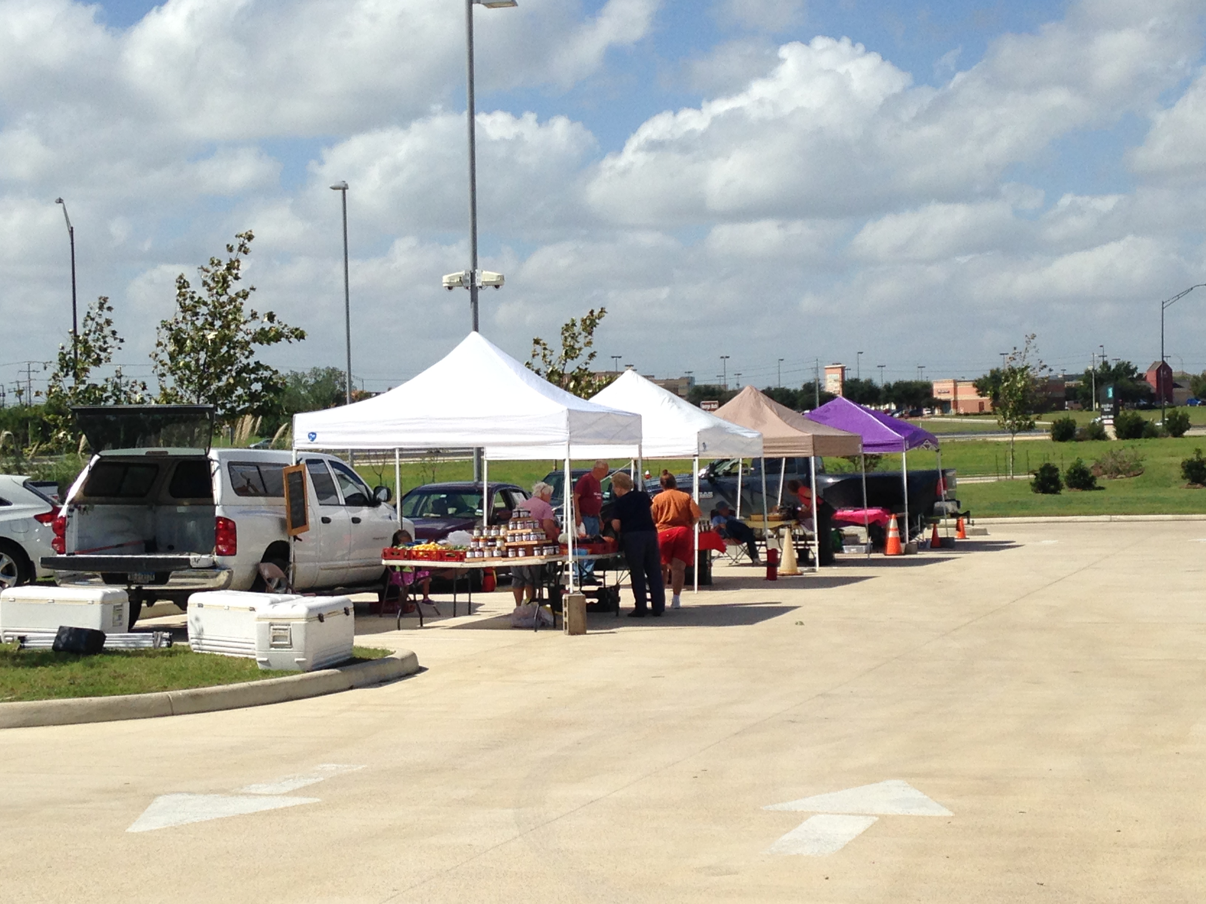

Mission

At Farm and City Market, we bring farmers and communities together. We help consumers know their farmers, understand how their food is produced, and learn how to prepare in-season local foods. We are committed to promoting the sustainability of local farms.

Our Brand

Farm and City Market grew from the collaboration of Home Town Food Policy Council, Home County Economic Development Council, and the Home Town Library. We foster community.